**The SAS CMS project**

**Testing Guide**

**Manpower**

*Document type: Guide*

*Document status:*

*Version: 1.0*

*Last changed: 07 June, 2012*

*Owner: José Cortés, Jeppesen*

Table of Contents

1 Introduction 5

1.1 This Document 5

1.2 Change History 5

2 Information for the Test Cases 6

3 Crew 7

3.1 Create a Crew Group 7

3.2 Crew Groups Visible 7

4 Scenarios 9

4.1 Create and Open a scenario 9

4.2 Bookmark 9

4.3 Reference Workset 9

4.4 Merge Scenario 9

5 Establishment 10

5.1 Establishment Views 10

5.2 Establishment bookmark 11

5.3 Drivers 11

5.3.1 Standard Parameter Drivers 11

5.3.2 Smearing Drivers 12

6 Training 14

6.1 Edit Course Templates 14

6.1.1 Create Course Template 14

6.1.2 Copy Course Template 14

6.1.3 Edit Course Template 15

6.1.4 Remove Course Template 15

6.1.5 Edit Course Block Template 15

6.1.6 Remove Course Block Template 15

6.1.7 Edit Training Effect Template 15

6.1.8 Remove Training Effect Template 16

6.2 Edit Courses 16

6.2.1 Create Course 16

6.2.2 Edit Course 16

6.2.3 Edit Course Blocks 16

6.2.4 Delete Course Blocks 16

6.2.5 Delete Course 17

6.2.6 Assign Participants 17

6.2.7 No Overlap a Courses with Leaves 17

6.2.8 Release Courses 17

6.2.9 Crew Publish 18

7 Seniority 19

7.1 Open Seniority View 19

8 Transition 20

8.1 InterBids Import 20

8.1.1 Import Bids 20

8.2 Show Transition Result View 20

8.3 Show Transition Crew Groups 20

8.4 Show Transition Matrix 20

9 Leave 21

9.1 Manually Edit of Leaves 21

9.1.1 Create, Edit and Remove Leaves 21

9.2 Automatic Leave Assignment 21

9.3 Rules 21

9.3.1 Show Crew Rule Failures 21

9.3.2 Accept and Consider Rule Failures 21

9.3.3 Warning Rules failures 22

9.3.4 Leave Rule Setting 22

9.4 Leave Entitlement 22

9.5 Edit Vacation Bids 22

9.6 InterBids Import and Export 23

9.6.1 Import Bids 23

9.6.2 Export Crew Info 23

9.7 Initiate season data for crew in filter 23

10 Reports 24

10.1 Establishment 24

10.1.1 map_establishment_tasks 24

10.2 Training 25

10.2.1 course_list 25

10.2.2 Schoolplan 26

10.2.3 Course_details 27

10.3 Transition 27

10.3.1 compare_transitions 27

10.3.2 transition_list 28

10.3.3 transition_matrix 29

10.4 Leave 30

10.4.1 assigned_vacation_list 30

10.4.2 bid_grantorder_list 31

10.4.3 bid_grantorder_on_day 32

10.4.4 bidding_list 33

10.4.5 crew_no_bid 34

10.4.6 crew_no_planned_vacation 35

10.4.7 illegal_bidding_list 36

10.4.8 illegal_bidding_list_incl_rotations 37

10.4.9 key_values 38

10.4.10 illegal_crew_list 39

10.4.11 overridden_rules_crew_list 39

11 New Test cases for SP5 41

11.1 Open more than one manpower application at the same time 41

11.2 Open Activity View 41

11.3 Open Activity View for specific crew 42

11.4 Export to Excel Establishment View 43

11.5 Consume Strategy 43

# Introduction

## This Document

This document contains the guidelines to test the SAS-specific Jeppesen Manpower application.

## Change History

|  |  |  |
| --- | --- | --- |
| Version | Author | Description |
| 1.0 | José Cortés | Document created |
| 1.1 | José Cortés | Review according to Lars’ feedback. |
| 1.2 | José Cortés | Adding new cases for SP5 |
|  |  |  |
|  |  |  |
|  |  |  |
|  |  |  |
|  |  |  |
|  |  |  |
|  |  |  |
|  |  |  |
|  |  |  |
|  |  |  |
|  |  |  |

# Information for the Test Cases

These rules are valid for all the test cases. The default workset is Main rank F, Start Date 01-12-2012, End date 31-1-2013, Day of operation: TODAY; the default crew group will be STO-36-FC. To ensure that you do not modify accidentally the master data you should create a scenario named “default_testing_scenario”. If you do not know how to create a scenario see chapter

When you are going to follow the different steps of a test case you do not need to reopen Manpower application or open a specific workset, in case that would be needed a specific workset or scenario would be indicated in the test case.

# Crew

## Create a Crew Group

Test case **CREW1**

Test that is possible to create a new crew group filter (i.e. *:38:STO:FC for flight deck) and check that filters correctly.

Steps:

1. Create Crew Group: Crew > Create Crew Group, Enter name: testingCrewGroup, Type: PLANNING, check Visible, Crew Group: *:38:STO:FC
2. Open Leave View: Go to the Workset Explorer windows, expand Leave and double-click on testingCrewGroup.
3. Open Crew View: Go to the Workset Explorer windows and double-click on Crew.
4. Filter Crew entering FC in Rank, STO in Base and AC Qual contains 38.

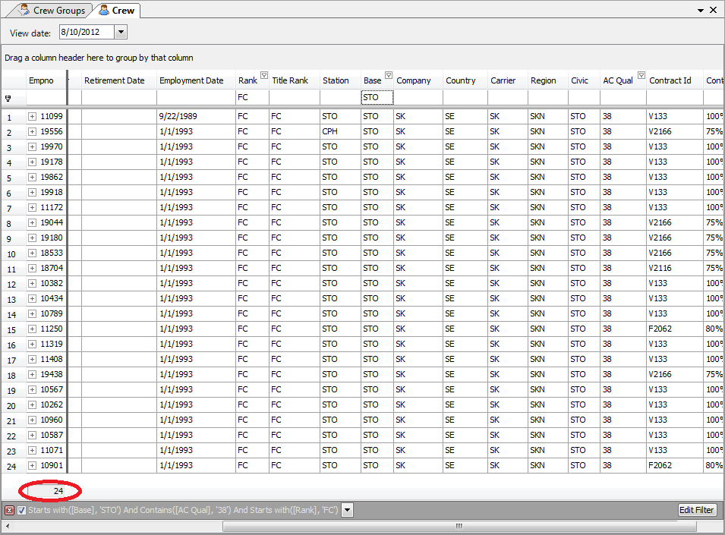

1. Finally check that the number of employees showed in both views (Crew View and Leave View) are the same.

## Crew Groups Visible

Test case **CREW2**

Test that the Crew Groups are shown and hidden in the Workset Explorer when you set Crew Groups as Visible and Invisible.

Steps: Select Crew > Show Crew Groups. Select the Visible checkbox for instance for the group STO-36-FC. The crew group will appear as entry under Establishment and Leave in Workset Explorer.

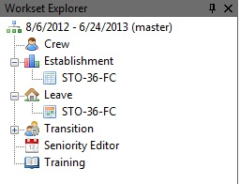

Now if you uncheck the Visible checkbox for instance for the group STO-36-FC. The crew group will disappear as entry under Establishment and Leave in Workset Explorer.

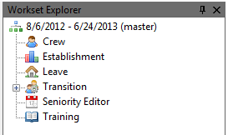

# Scenarios

## Create and Open a scenario

Test case **SCEN1**

Test to create and open a scenario.

Steps: Once you have opened a workset, select File > Save as. Enter a scenario name (for instance testing_scenario).

Exit and Open again Manpower. Open the Workset form and fill the Scenario/Revision field as “SCEN: [scenario name]” (for instance, SCEN: testing_scenario).

## Bookmark

Test case **SCEN2**

Test to create and open a bookmark

Steps: Once you have opened a workset, select File > Save as. Enter a scenario name (for instance testing_scenario) and enter a bookmark name (for instance, test_bookmark)

## Reference Workset

Test case **SCEN3**

To test that it is possible to open a Reference workset.

Steps: File > Open Reference Workset

## Merge Scenario

Test case **SCEN4**

To test that, you should be working on a scenario.

Steps: File > Merge

Then when you do the Merge the scenario (and the revision connected to it) will be removed after the merge. Bookmarks pointing to the scenario will point at the master workset after the merge.

# Establishment

## Establishment Views

Test case **ESTA1**

To test that the different Establishment views: Establishment Overview, Establishment Detail View, Establishment Graph view can be opened and are correctly displayed depending on the selected view values.

Steps to follow:

1. Select Establishment > Show Establishment Overview.
2. You do not need to modify any of the fields in the form, click OK.
3. The Establishment Overview will be displayed

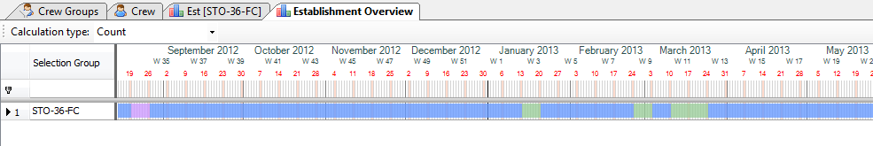

1. Select Establishment > Show Establishment Detail View.
2. Select a crew group and click OK.
3. The Establishment Detail View will be displayed.

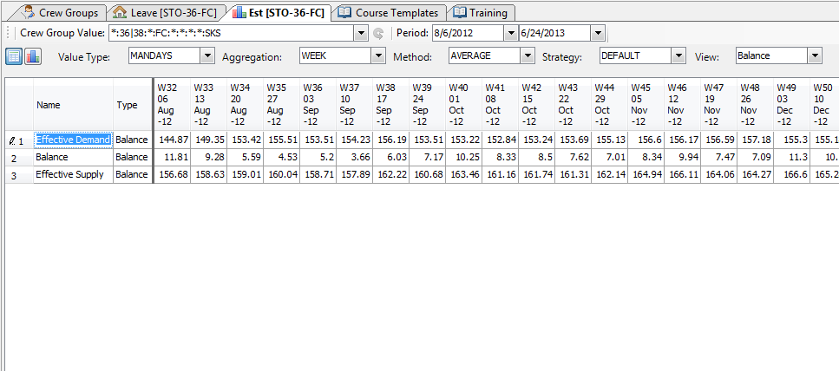

1. Click on the Chart icon.

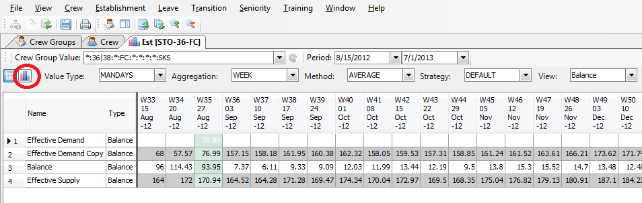

1. The Establishment Graph view will be displayed

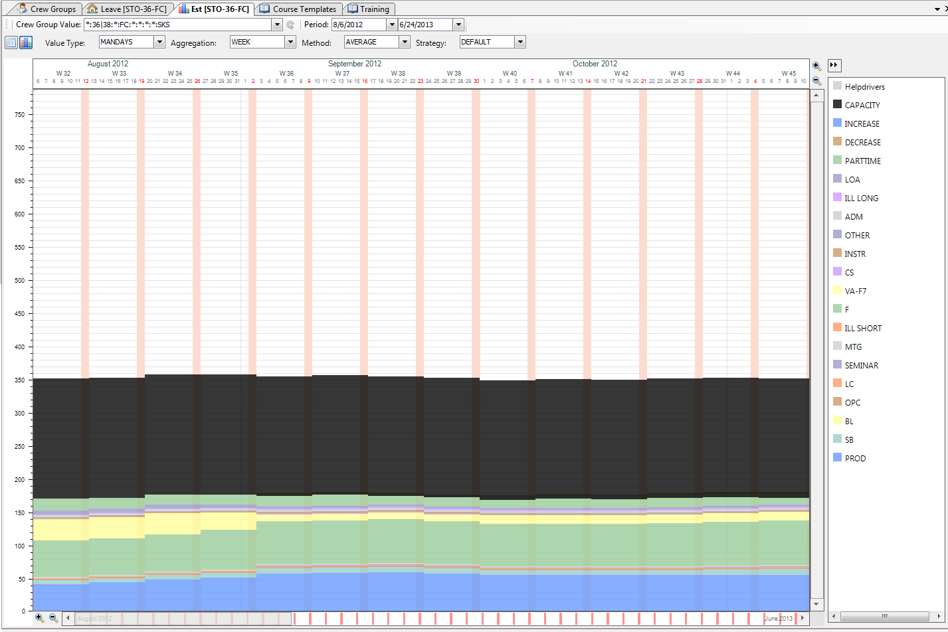

## Establishment bookmark

Test case **ESTA2**

Test to compare Establishment tables by using Sum and Difference and check that the result tables show correct results.

Steps: It should be opened a Reference Workset (see Chapter Scenarios, Reference Workset)

Select Establishment > Reference > Show Reference Establishment Detail View.

Select Establishment > Compare Tables > Difference. Check a couple of values in the Difference Table and see that those values are really the difference between the tables.

Select Establishment > Compare Tables > Sum. Check a couple of values in the Sum Table and see that those values are really the sum of both tables.

## Drivers

### Standard Parameter Drivers

Test case **DRIV1**

To test that it is possible to create a Standard Parameter driver.

Steps:

1. From the Establishment menu select Establishment Config > Hierarchy Manager.
2. Create a new driver: Expand the node Migrated > New Balance > New Effective Demand > Activity_Group___VACATION > Activity___VAC > Sum_Planned___VAC. Right-click on the Sum_Planned__VAC Node and select Create Child > DRIVER. Call it “TestStand”. Select DriverStdParamForm_.
3. Add the created Driver Node to the Standard Layout > Effective Demand > VACATION > VAC > Sum Planned using drag and drop.
4. Close the Establishment Hierarchy.
5. Open the Drivers View from Establishment menu ShowDrivers....
6. Fill in the Standard Parameters tab; right-click on the row for your newly created driver and select Create Standard Parameter.... Call it “TestStand p”. Select your Crew Group and click ok.
7. Expand the “TestStand p” Node in Drivers View. Right-click on the newly created Standard Parameter in the Standard Parameters and choose Create Value... from the context menu. Create values; 10 from 2012-12-01
8. Open Establishment Detail table for your Crew Group or recalculate if view is already opened. Check the values from your driver, the value for each day should be 10 since 2012-12-01.

### Smearing Drivers

Test case **DRIV2**

To test that it is possible to create a Smearing driver with no dependency and standard parameter type: ABS, and see that it gives correct values. Check that the Smearing driver adds values where the difference between supply and demand is the biggest, to even out the differences.

Steps:

1. From the Establishment menu select Establishment Config > Hierarchy Manager.
2. Create a new driver: Expand the node Migrated > New Balance > New Effective Demand > Activity_Group___VACATION > Activity___VAC > Sum_Planned___VAC. Right-click on the Sum_Planned__VAC Node and select Create Child > DRIVER. Call it “TestSmear”, select DriverSmearing_, calculation order 999 (the Smearing Driver should calculate after the rest of drivers to be able to even out properly the difference supply and demand).
3. Add the created Driver Node to the Standard Layout > Effective Demand > VACATION > VAC > Sum Planned using drag and drop.
4. Close the Establishment Hierarchy.
5. Open the Drivers View from Establishment menu ShowDrivers....
6. Fill in the Standard Parameters tab; right-click on the row for your newly created driver and select Create Standard Parameter.... Call it “TestSmear p”. Select your Crew Group and click ok.
7. Expand the “TestSmear p” Node in Drivers View. Right-click on the newly created Standard Parameter in the Standard Parameters and choose Create Value... from the context menu. Create values; 100 from 2012-12-01 and 0 from 2013-1-1.
8. Open Establishment Detail table for your Crew Group or recalculate if view is already opened. Check the values from your driver, the value 100 should be smearing from 2012-12-01 to 2012-12-31.

Test case **DRIV3**

To test that it is possible to create a Smearing driver with dependency and standard parameter type: PERC, and see that it gives correct values. Check that the Smearing driver adds values where the difference between supply and demand is the biggest, to even out the differences.

Steps:

1. From the Establishment menu select Establishment Config > Hierarchy Manager.
2. Create a new driver: Expand the node Migrated > New Balance > New Effective Demand > Activity_Group___VACATION > Activity___VAC > Sum_Planned___VAC. Right-click on the Sum_Planned__VAC Node and select Create Child > DRIVER. Call it “TestSmear2”, select DriverSmearing_, calculation order 999 (the Smearing Driver should calculate after the rest of drivers to be able to even out properly the difference supply and demand) and Dependent Node as Activity_Group___F.
3. Add the created Driver Node to the Standard Layout > Effective Demand > VACATION > VAC > Sum Planned using drag and drop.
4. Close the Establishment Hierarchy.
5. Open the Drivers View from Establishment menu ShowDrivers....
6. Fill in the Standard Parameters tab; right-click on the row for the newly created driver and select Create Standard Parameter.... Call it “TestSmear2 p”. Select your Crew Group, select PERC as Parameter Type and click ok.
7. Expand the “TestSmear2 p” Node in Drivers View. Right-click on the newly created Standard Parameter in the Standard Parameters and choose Create Value... from the context menu. Create values; 50 from 2012-12-01 and 0 from 2013-1-1.
8. Open Establishment Detail table for your Crew Group or recalculate if view is already opened. Check the values from your driver, the values smeared from 2012-12-01 to 2012-12-31 should be the 50% of sum of Activity Group F value from 2012-12-01 to 2012-12-31.

# Training

## Edit Course Templates

### Create Course Template

Test case **COUR1**

Test to create a Course Template.

Steps:

1. To Open the Course Template View you should go to Training > Show Course Templates. Afterwards go to Training > Template > Create Course Template.
2. Call it “testCourseTemp”, course type CONV, Qualification obtained ACQUAL+36, Training Position FC 1, FP 1.
3. Once the course template was created this one should be listed in the Course Template View.
4. Create a Course Block Template: Select the course just created and click on Training > Templates > Create Course Block Template.
5. Select Block Type “CLASSROOM” and check Fixed Block Length and click OK.
6. It will appear a form, just click OK.
7. Create another Course Block Template: Select the course just created and click on Training > Templates > Create Course Block Template.
8. Select Block Type “LIFUS” and check Fixed Block Length and click OK.
9. It will appear a long form, just click OK.
10. Create a Training Effect. Select the LIFUS Course Block just created and right-click on it, select Create Training Effect. Enter a name i.e. TrainingEffectTest and click OK.
11. It will be displayed a form, just set Field Value as FP and click Finish.
12. Finally we have created the Course Template, now we will create a course using this course template.
13. Go to Workset Explorer and double-click on Training.
14. Select Training > Create Course
15. Set Carrier as SK, Airport as ARN, Course name as TestCourse1, Default from crew group as STO-36-FC, Default to crew group as STO-36-FC, Course Template as testCourseTemp and click Next.
16. It will appear a new form, click OK.

### Copy Course Template

Test case **COUR2**

Test to create a copy of a Course Template.

Steps:

1. To Open the Course Template View you should go to Training > Show Course Templates.
2. Right click on a course template and select Copy Course Template.
3. Call it “CopyCourse”
4. It will appear a new form, click OK
5. Once the copy of a course template was created this one should be listed in the Course Template View.

### Edit Course Template

Test case **COUR3**

Test to edit a Course Template.

Steps:

1. To Open the Course Template View you should go to Training > Show Course Templates.
2. Right click on a course template and select Edit Course Template.
3. Select another Course Type and increase or decrease the value of FC or FP. Click OK.
4. Select Edit Course Template for the same course and check that the new values has been saved.

### Remove Course Template

Test case **COUR4**

Test to remove a Course Template.

Steps:

1. To Open the Course Template View you should go to Training > Show Course Templates.
2. Right click on a course template and select Remove Course Template.
3. Check that the Course Template has been removed from the Course Template List.

### Edit Course Block Template

Test case **COUR5**

Test to edit a Course Block Template.

Steps:

1. To Open the Course Template View you should go to Training > Show Course templates.
2. Expand course template, select one of the Course Block, right-click on it and select Edit Course Block Template.
3. Modify for instance the Max. Number of Days and the number of activities and click OK.
4. Check that the changes have been saved.

### Remove Course Block Template

Test case **COUR6**

Test to remove a Course Block Template of a Course Template.

Steps:

1. Expand course template, select one of the Course Block, right-click on it and select Remove Course Block Template.
2. Check that the Course Block Template has been removed.

### Edit Training Effect Template

Test case **COUR7**

Test to edit a Training Effect Template of a Course Block Template.

Steps:

1. Expand course template, expand one of the Course Block, right-click on one of the Training Effects and select Edit Training Effect Template.
2. For instance select another of Field Value and click Ok.
3. Check that the changes have been saved.

### Remove Training Effect Template

Test case **COUR8**

Test to remove a Training Effect Template of a Course Block Template.

Steps:

1. Expand course template, expand one of the Course Block, right-click on one of the Training Effects and select Remove Training Effect Template.
2. Check that the Training Effect Template has been removed.

## Edit Courses

### Create Course

Test case **COUR9**

Test to create a Course.

Steps:

1. Go to Workset Explorer and double-click on Training.
2. Select Training > Create Course
3. Set Carrier as SK, Airport as ARN, Course name as TestCourse1, Default from crew group as STO-36-FC, Default to crew group as STO-36-FC, Course Template for instance “38 REFRESHER >5year spes jan2011” and click Next.
4. It will appear a new form, click OK.
5. Once the course was created this one should be listed in the Training View.

### Edit Course

Test case **COUR10**

Test to edit a Course.

Steps:

1. Select one of the Course, right-click on it and select Edit course.
2. Modify any of the fields and click OK.
3. Check that the changes have been saved.

### Edit Course Blocks

Test case **COUR11**

Test to edit a Course Blocks of a Course.

Steps:

1. Expand course, expand Type: Resources, select one of the Course Block, right-click on it and select Edit Course Block.
2. Modify any of the fields and click OK.
3. Check that the changes have been saved.

### Delete Course Blocks

Test case **COUR12**

Test to edit a Course Blocks of a Course.

Steps:

1. Expand course, expand Type: Resources, select one of the Course Block, right-click on it and select Remove Course Block.
2. Check that the Course Block was removed.

### Delete Course

Test case **COUR13**

Test to verify that it is possible to delete an open course from Training view and that it is successfully deleted.

Steps: Select one course and right-click on it, select Remove Course. Check that the course was removed.

### Assign Participants

Test case **COUR14**

Test that it is possible to Assign participants on a Course.

Steps:

1. Create Course following the steps of the test case Create Course described above.
2. Right-click on this new course and select Assign Participants.
3. Assign the participants and click OK.
4. Check that the participants were assigned to the course expanding the course and expanding the Type:

Test case **COUR15**

Test that it is possible to assign participants on a Course with training Effects.

Steps:

1. Create Course following the steps of the test case Create Course described above.
2. Right-click on this new course and select Assign Participants.
3. Assign the participants and click OK.
4. See the training effects for the participants selecting the course and right-click on it and select Show Crew Training Effects.

### No Overlap a Courses with Leaves

Test case **COUR16**

Once you have created a Course and assigned the participants try to create a vacation leave for one of the participants that overlap the training. It should be displayed a warning message.

Test case **COUR17**

Try to assign one participant to a Course that overlaps on a vacation leave created previously. It should be displayed a warning message.

### Release Courses

Test case **COUR18**

Test that is not possible to release a course when there are not assigned all participants.

Test case **COUR19**

Test that when a course is released:

* The Establishment calculation stops using the Manpower Course object in the calculations.
* Crew info is updated with the training effects.
* Training need is updated for all flight course blocks.

### Crew Publish

Test case **COUR20**

Test to publish the training activities for that course selecting Crew Publish Course. All training activities created for this course for all the crew assigned to the course will be published and visible for crew in Crew Portals.

# Seniority

## Open Seniority View

Test case **SENI1**

Test that it is possible to open the Seniority View. Select Seniority > Show Seniority Editor.

The Seniority View should be opened.

# Transition

## InterBids Import

### Import Bids

Test case **TRAN1**

Test that it is possible to import bids.

Steps:

1. Select Transition > Import Bids.
2. Select the file to import.
3. Expand Transition node in Workset Explorer Windows and double-click on Biddings.
4. The Biddings Tab will be displayed
5. Check that the new bids imported are in this Bid List.

## Show Transition Result View

Test case **TRAN2**

Test that it is possible to display the Transition Result View. Select Transition > Show Transition Result View.

## Show Transition Crew Groups

Test case **TRAN3**

Test that it is possible to display the Transition Crew Groups. Expand Transition node in Workset Explorer Windows and double-click on Crew Groups.

## Show Transition Matrix

Test case **TRAN4**

Test that it is possible to display the Transition Matrix. Expand Transition node in Workset Explorer Windows, expand the node Result and double-click on Transition Matrix.

# Leave

## Manually Edit of Leaves

### Create, Edit and Remove Leaves

Test case **LEAV1**

Test that is possible create, edit and remove leaves.

Steps: Select one of the crew member in the Leave View, select Leave > Create Leave. Enter VA as code, enter a Period Start and Period End and click OK. If it is displayed a warning rules failures list, you can ignore it and click OK.

Test case **LEAV2**

Test that is not possible to create a leave that overlaps with other leaves.

Steps: First of all we create a leave and afterwards we create another leave that overlaps the first leave. To create a leave we can follow the steps described on the previous test case.

## Automatic Leave Assignment

Test case **LEAV3**

Test that Automatic Leave Assignment and Clear Automatic Assignment work correctly in the Leave view, check that the granted bid order follows the right order according to comparers.

**NOTE:** Open a workset which contains a whole season according to be able to execute the Automatic Leave Assignment. For instance between 1-5-2012 and 31-10-2012, Main Rank: F and Day of operation TODAY.

Test case **LEAV4**

Modify the comparers (Leave > Automatic Assigner Config > Automatic Assigner) and run the automatic leave assignment again and check that the new order is according to the new comparer criterion.

**NOTE:** Open a workset which contains a whole season according to be able to execute the Automatic Leave Assignment. For instance between 1-5-2012 and 31-10-2012, Main Rank: F and Day of operation TODAY.

## Rules

### Show Crew Rule Failures

Test case **LEAV5**

Test that is displayed a list of all rule failures for this Crew group (Leave > Show Crew Rule Failures)

### Accept and Consider Rule Failures

Test case **LEAV6**

Test that the rule failures disappear of the list of Crew Rule Failures if you Accept Rule Failures for a specific Crew member or Crew in Group.

Steps:

1. Check that is activate the rule min_days_between_activities, active it in case that is not activated.
2. Create to Leaves with one day between both Leaves.
3. Ignore the warning message.
4. Right-click over this crew member and select Accept Rule Failures.
5. Open Show Crew Rule Failures and check that there is no rule failure min_days_between_activities for this crew member.
6. Now if you right-click on the same crew member and select Consider Rule Failure
7. Open Show Crew Rule Failures again and check that now there is a rule failure min_days_between_activities for this crew member.

### Warning Rules failures

Test case **LEAV7**

Test that is displayed a warning message when one of the leave manually created causes a rule failure.

Steps:

1. Check that is activated the rule min_days_between_activities, active it in case that is not activate.
2. Create to Leaves with one day between both Leaves.
3. It should be displayed a warning message informing us that there is min_days_between_activities rule failure (it could be more rule failures in case the leave cause other illegalities)

### Leave Rule Setting

Test case **LEAV8**

Activate and deactivate some leave rules and test that is only listed the rule failures according of the rule settings when you create Leaves. (Leave > Configure Leave Setting)

## Leave Entitlement

Test case **LEAV9**

Test the entitlement for crew with and without temporal contract during the entitlement period. The entitlement calculation is explained in the Functional Reference Manual (chapter 8.14.3 Leave entitlement and reduction calculation)

## Edit Vacation Bids

Test case **LEAV10**

Create, edit and remove some vacations bids and check that the vacations bids are correctly updated.

Test case **LEAV11**

Test that is possible to grant and ungrant vacation bid.

Steps:

1. Open the Leave View (if it is not already opened)
2. Expand the info for a crew member.
3. Go to Vacation bid tab.
4. Right-click on one of the bids and select Grant Bid.
5. Check in the roster that the bid has been granted.
6. Now right-click on the bid just granted and select Ungrant Bid.
7. Check in the roster that the bid is not granted anymore.

## InterBids Import and Export

### Import Bids

Test case **LEAV12**

Test that it is possible to import Bids selecting the command Leave > Import Bids.

### Export Crew Info

Test case **LEAV13**

Test that it is possible to import Export Crew info selecting the command Leave > Export Crew info.

## Initiate season data for crew in filter

Test case **LEAV14**

Execute the command Leave > Initiate season data for crew group. This command should do:

* Recalculates crew points
* Recalculates vacation rotations
* Recalculates Christmas rotations

# Reports

## Establishment

### map_establishment_tasks

Test case **REPO1**

Execute the map_establishment_tasks report. Select Establishment > Generate Establishment Report, select map_establishment_tasks report.

This report is a list of all task codes in the system. It lists if there are codes that have not been mapped to establishment, and if there are codes that are mapped but doesn’t exist. It lists codes both for cabin and flight deck, and takes the values from the database, and does not include local changes to establishment.

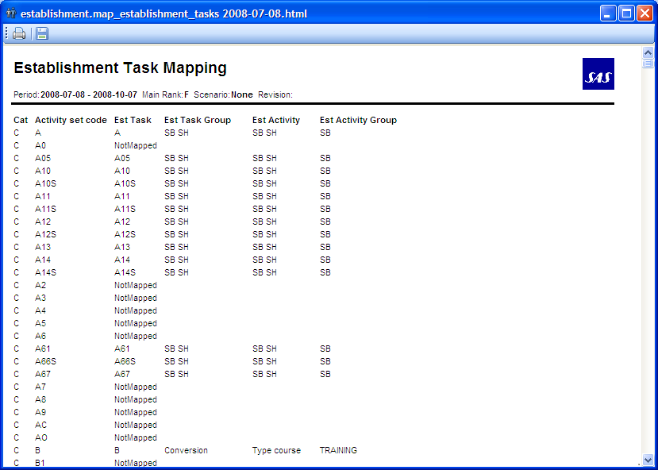

## Training

### course_list

Test case **REPO2**

Execute the course_list report. Select Training > Generate Training Report, select course_list report.

This report is a list of courses available sorted on startdate.

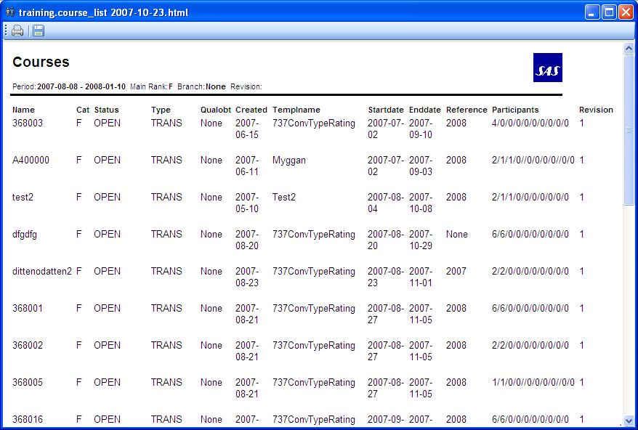

### Schoolplan

Test case **REPO3**

Execute schoolplan report. Select Training > Generate Training Report, select schoolplan report.

The report contains information about course blocks, assigned participants, their from- and to-filters etc. Empno, seniority, rank, qual and station is crewinfo valid on the day before course start.

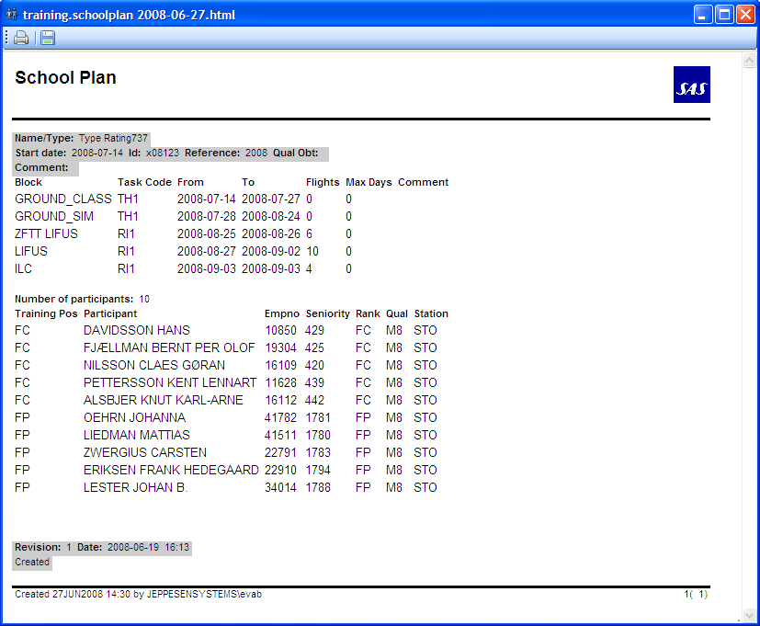

### Course_details

Test case **REPO4**

Execute the course_details report. Select Training > Generate Training Report, select course_details report.

This report shows detailed information about a course such as course blocks, training effects and course revisions.

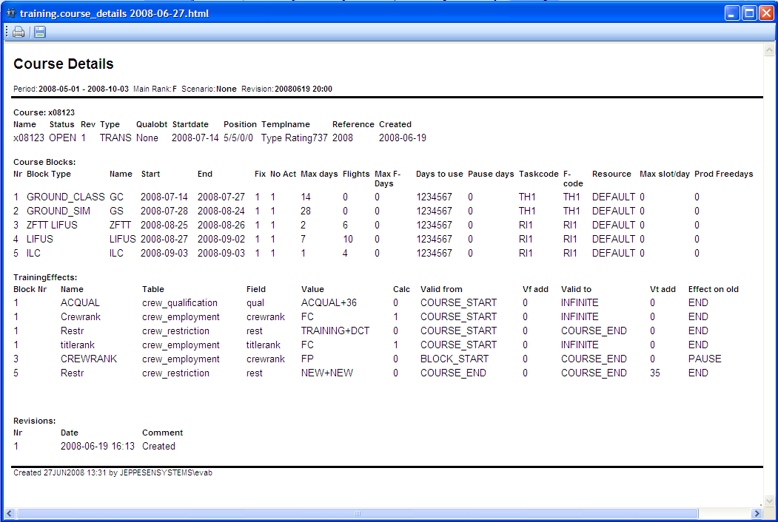

## Transition

### compare_transitions

Test case **REPO5**

Execute the compare_transitions report. Select Transition > Generate Transition Report, select compare_transitions report.

The report shows the difference between a transition done in a reference workset and a current open workset.

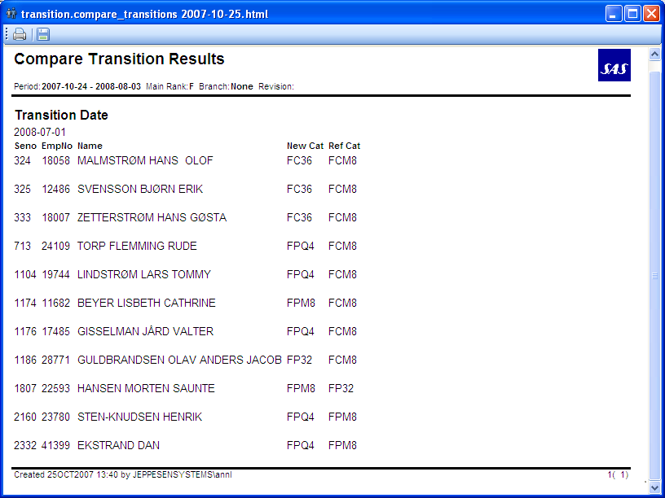

### transition_list

Test case **REPO6**

Execute the transition_list report. Go to Transition > Generate Transition Report, select transition_list report.

The report lists all crew, in seniority order, who have been assigned to new groups in the transition run.

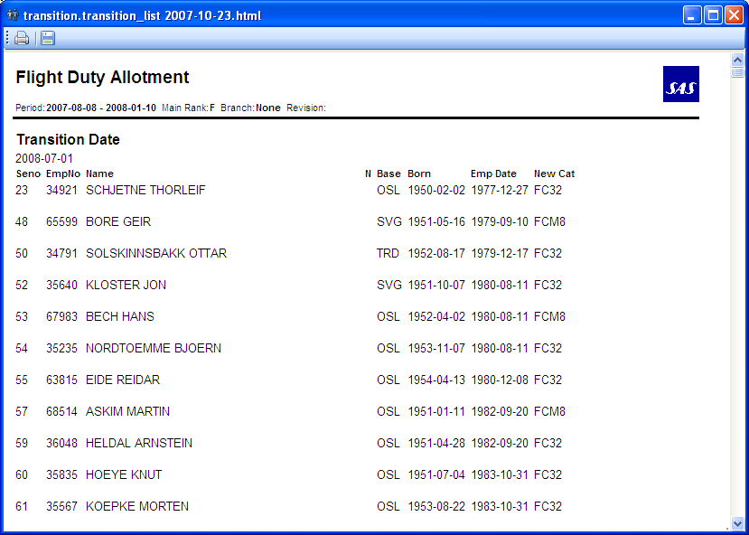

### transition_matrix

Test case **REPO7**

Execute the transition_matrix report. Select Transition > Generate Transition Report, select transition_matrix report.

The transition matrix is a summary of the effects of one transition run, similar to the one available through Workset Explorer.

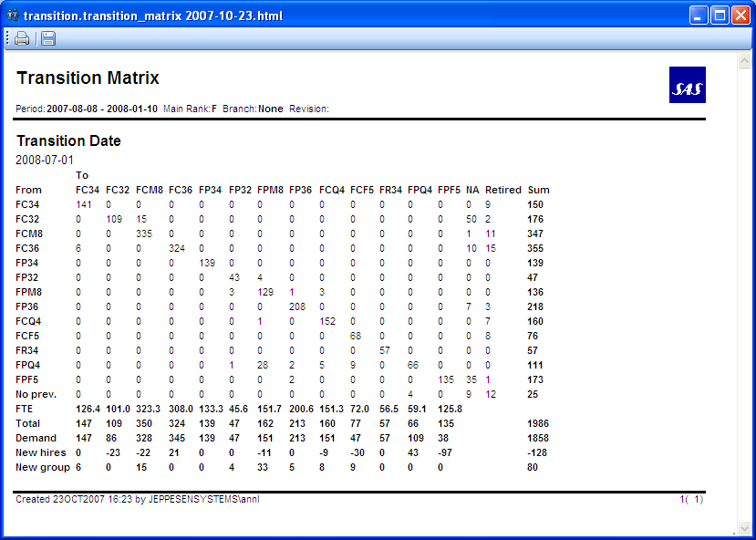

## Leave

### assigned_vacation_list

Test case **REPO8**

Execute the assigned_vacation_list report. Select Leave > Generate Leave Report, select assigned_vacation_list report.

The report is a list containing all crew in the filter and their assignments, bids and preactivities for the selected season.

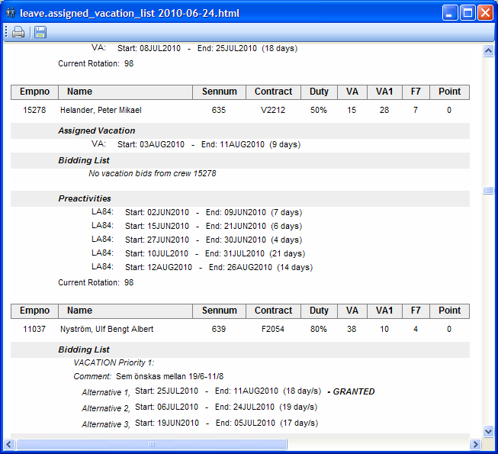

### bid_grantorder_list

Test case **REPO9**

Execute the bid_grantorder_list report. Select Leave > Generate Leave Report, select bid_grantorder_list report.

This report shows the order in which the bids will be/are granted by the automatic leave assigner.

Only vacation bids within selected season are shown. Granted bids are marked as granted.

After a granted Vacation bid, the corresponding assigned vacation is shown.

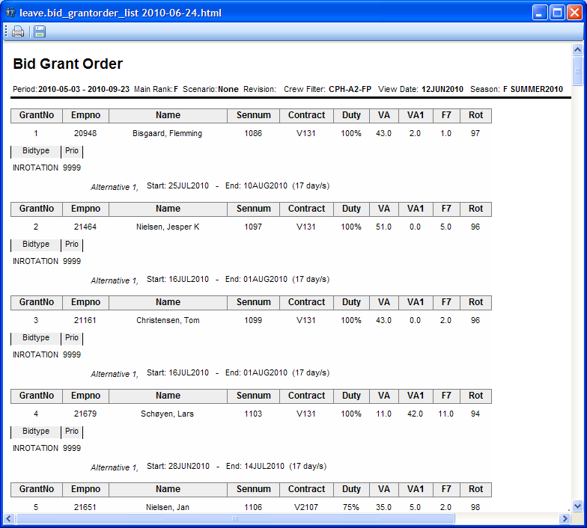

### bid_grantorder_on_day

Test case **REPO10**

Execute the bid_grantorder_on_day report. Select Leave > Generate Leave Report, select bid_grantorder_on_day report.

This report only shows the bids that have an alternative that covers the view date. The bids are displayed in the same order as bid_grantorder_list, that is according to the leave comparer set.

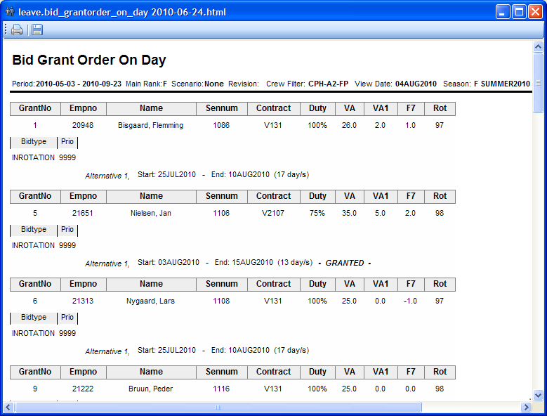

### bidding_list

Test case **REPO11**

Execute the bidding_list report. Select Leave > Generate Leave Report, select bidding_list report.

This report is a list containing all crew in the filter and their current bids for the selected season. Under Preactivities personal activities and published vacation is displayed.

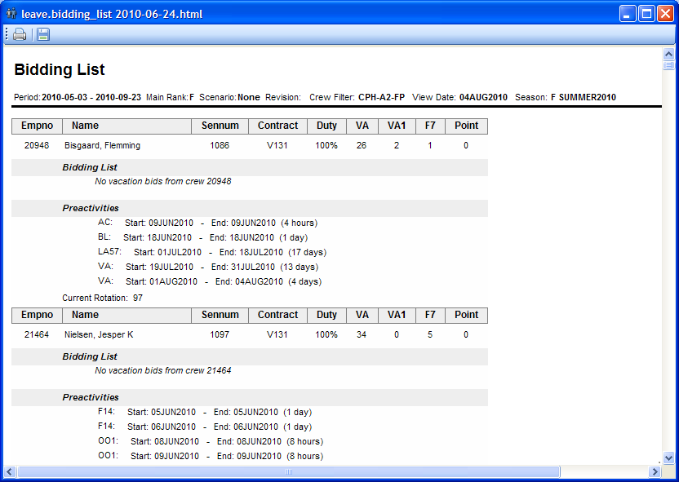

### crew_no_bid

Test case **REPO12**

Execute the crew_no_bid report. Select Leave > Generate Leave Report, select crew_no_bid report.

This report is a list containing all crew in the filter without any current bids for the selected season. Preassigned activities and published vacation will also be displayed.

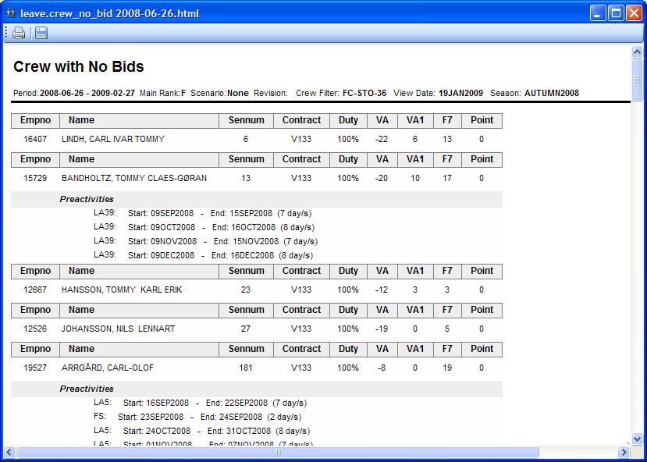

### crew_no_planned_vacation

Test case **REPO13**

Execute the crew_no_planned_vacation report. Select Leave > Generate Leave Report, select crew_no_planned_vacation report.

This report is a list of crew that hasn’t been assigned any vacation during the set season. Preactivities, balances and bids are also shown.

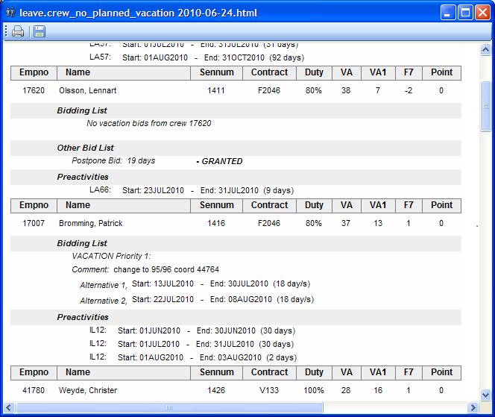

### illegal_bidding_list

Test case **REPO14**

Execute the illegal_bidding_list report. Select Leave > Generate Leave Report, select illegal_bidding_list report.

This report contains all bids considered illegal with the current rules. The system tries to assign the bids, and reports all the illegalities it finds.

If crew already has assignments representing the bid, the bid can also be marked as illegal because of overlapping activities.

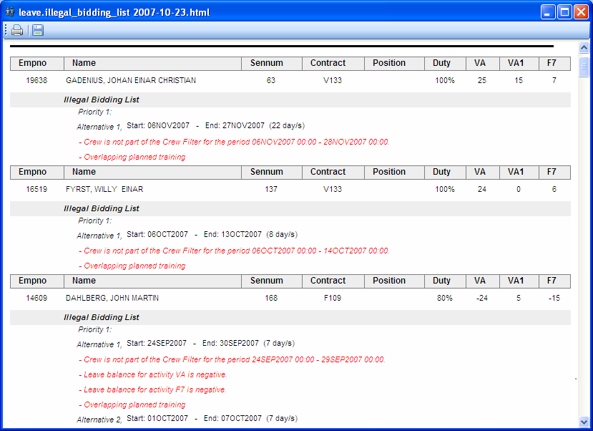

### illegal_bidding_list_incl_rotations

Test case **REPO15**

Execute the illegal_bidding_list_incl_rotations report. Select Leave > Generate Leave Report, select illegal_bidding_list_incl_rotations report.

This report contains a list of all crew and the corresponding illegal bids they have.

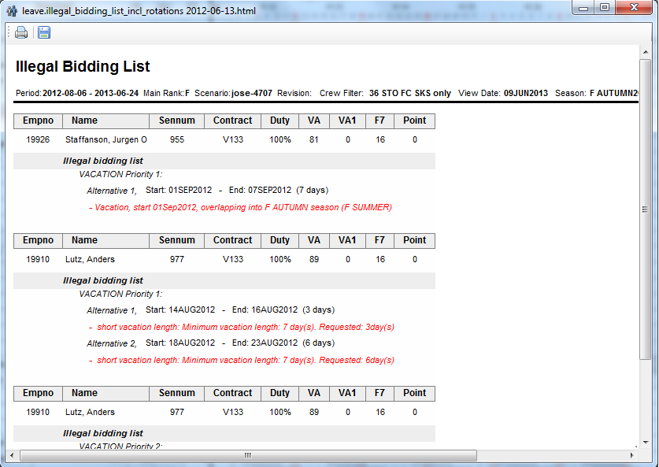

### key_values

Test case **REPO16**

Execute the key_values report. Select Leave > Generate Leave Report, select key_values report.

This report list a number of key values that can be used to evaluate the current state of leave assignment for crew in filter. The report uses the date selected as ‘View Date’ as input date.

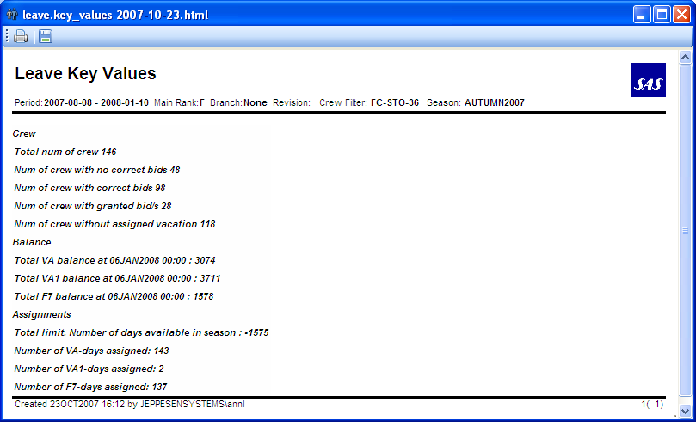

### illegal_crew_list

Test case **REPO17**

Execute the illegal_crew_list report. Select Leave > Generate Leave Report, select illegal_crew_list report.

This report shows all crew with illegalities and their rule failures. This report is season independent, and is possible to run no matter what season is set. The resulting illegalities are also all the illegalities found for the crew, covering the entire open workset.

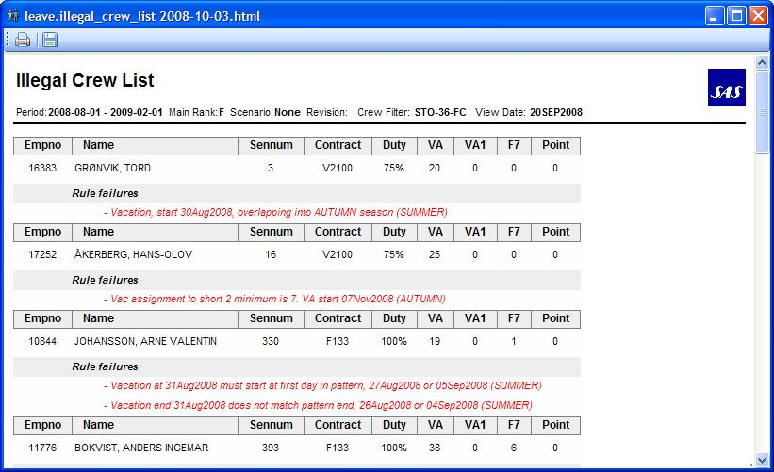

### overridden_rules_crew_list

Test case **REPO18**

Execute the overridden_rules_crew_list report. Select Leave > Generate Leave Report, select overridden_rules_crew_list report.

The report contains all crew that have overridden rules and what rules that have been overridden. This report is season independent, and is possible to run no matter what season is set. The resulting illegalities are also all the illegalities found for the crew, covering the entire open workset.

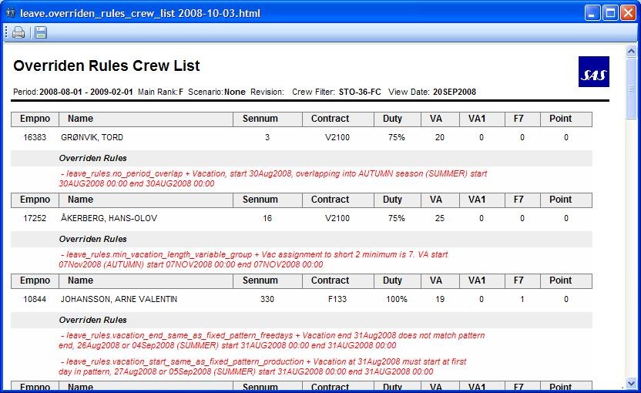

# New Test cases for SP5

## Open more than one manpower application at the same time

Open from the launcher three manpower applications at the same time. For example the workset to open for each manpower application could be:

First workset: Main rank F, Start Date 01-12-2012, End date 31-12-2012, Day of operation TODAY.

Second workset: Main rank C, Start Date 01-1-2012, End date 31-1-2013, Day of operation TODAY.

Third workset: Main rank F, Start Date 01-12-2012, End date 31-1-2013, Day of operation TODAY.

## Open Activity View

Expand Activity in the Workset Explorer and double click on STO-36-FC.

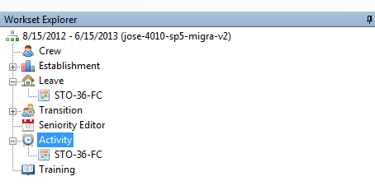

This is how it looks the Activity View:

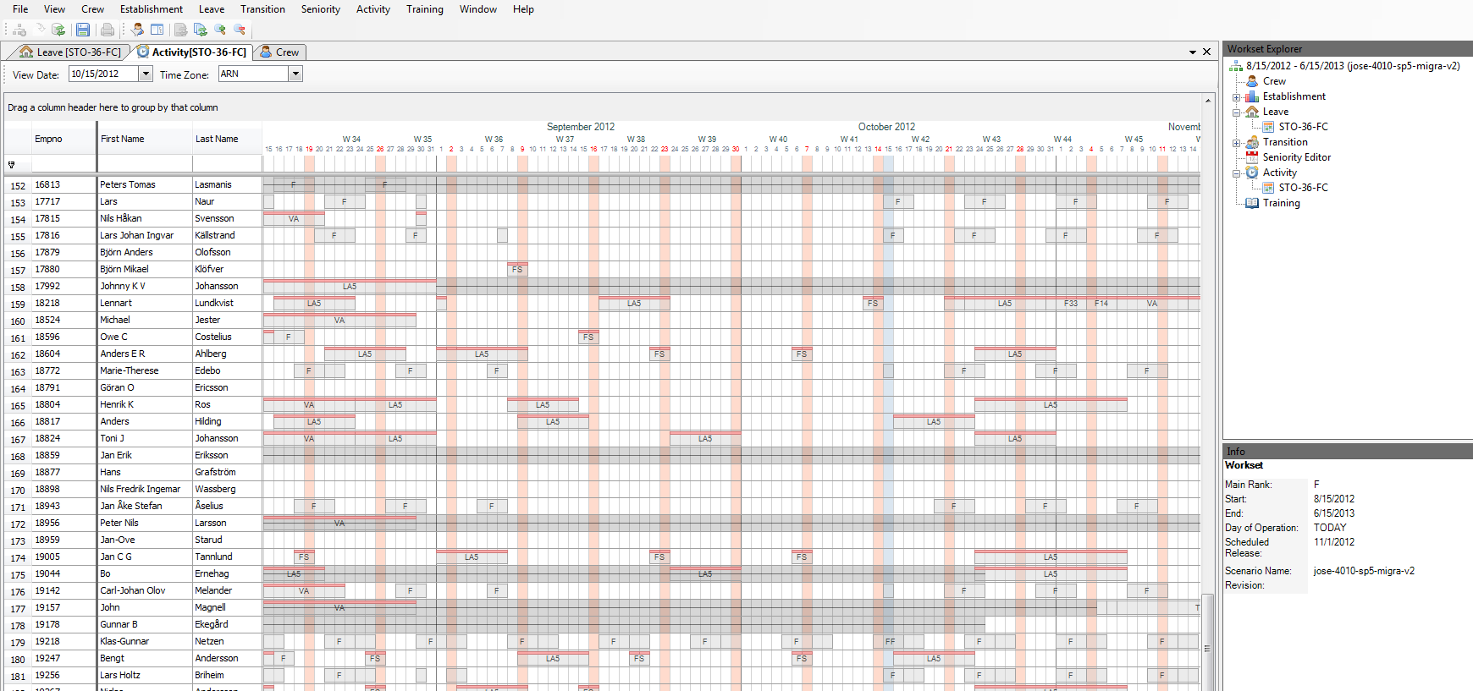

Now click on different Leave objects and check that the information of the leave object is displayed in Info Window.

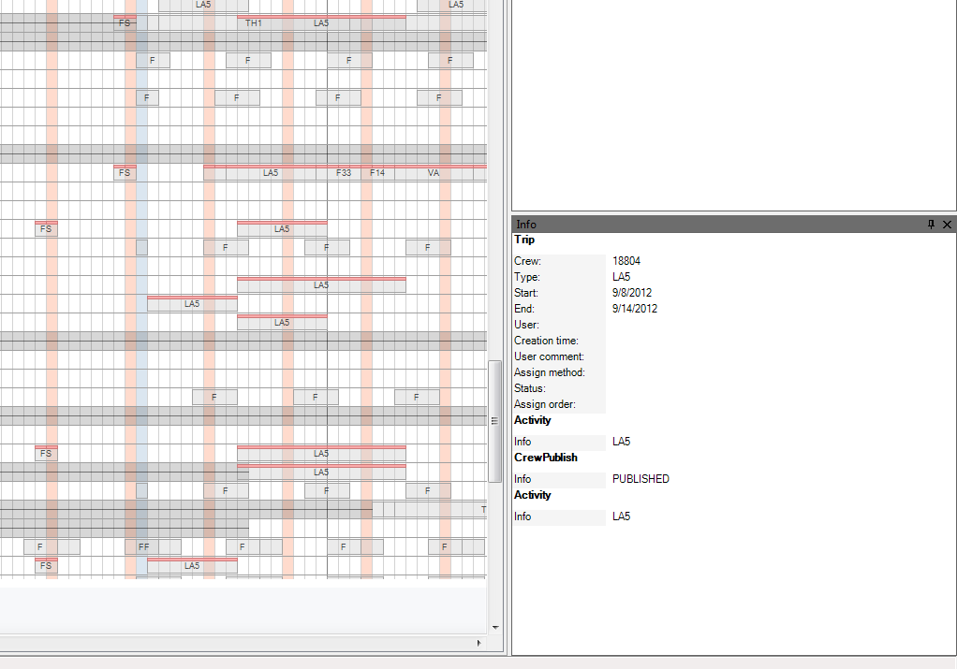

## Open Activity View for specific crew

Once the Activity View is open, select Activity > Open Activity View For crew.

Introduce a crewid, for example 16312, and click OK. It should be open a new Activity View just for that crewed.

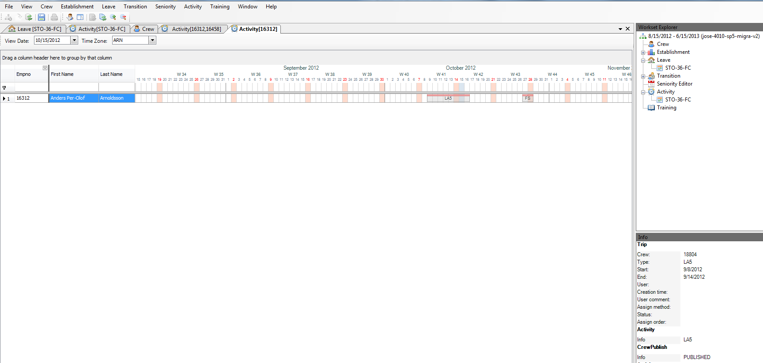

Now repeat the steps above but now introduce a list of crewids separated by commas, for example 16312, 16458.

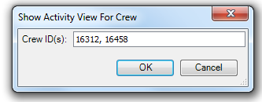

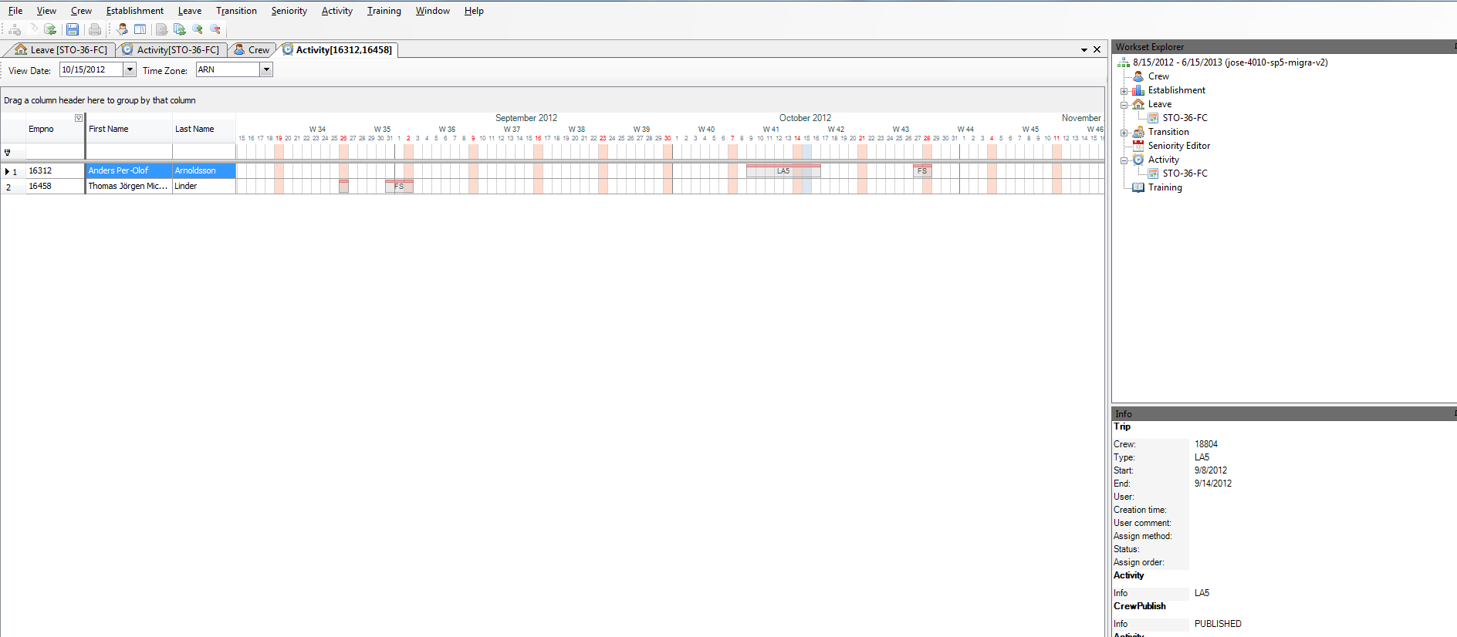

## Export to Excel Establishment View

Open the Establishment View, in case that it was not already open. Select File > Export to Excel. The excel file should be created properly.

## Consume Strategy

In SP5 is been added new Strategies in the Establishment View. This new strategies are

WEEK, WEEK-INT, MONTH, MONTH-INT, YEAR, YEAR-INT

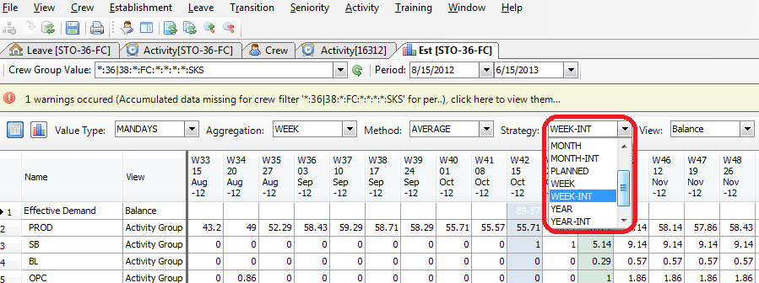

Open the Establishment View, in case that it was not already open. Select each new strategy and check that is actually working.

(You can see an example of how it works in the consume strategy document.)